UDACITY

**Christopher Damian Munene**

**Introduction to Generative AI with AWS**

**Project Documentation Report**

Visit [UDACITY Introduction to Generative AI with AWS Project Documentation Report](https://docs.google.com/document/d/1kqRy-gVGZjwl9r03hqMeWSm-D6hEY8KWuxz4GO0vdOw/copy) to make a copy of this document.

Complete the answers to the questions below to complete your project report. Create a PDF of the completed document and submit the PDF with your project.

|  |  |
| --- | --- |
| Question | Your answer: |
| **Step 2: Domain Choice**  What domain did you choose to fine-tune the Meta Llama 2 7B model on?  Choices:   1. Financial 2. Healthcare 3. IT | Financial Domain |
| **Step 3: Model Evaluation Section**  What was the response of the model to your domain-specific input in the **model_evaluation.ipynb file**? | the relative volume for the long out of the money options, indicates  > that the option market is pricing in a 25.0% move from the current price of 15.10.  AAPL has an average true range (ATR) of 1.21. Other technical indicators are worth considering in assessing the prospects for EPS  ================================== |
| **Step 4: Fine-Tuning Section**  After fine-tuning the model, what was the response of the model to your domain-specific input in the **model_finetuning.ipynb file**? | The results are encouraging for aggressive investors  > [{'generated_text': ' looking to capitalize on the ongoing recovery in the housing market.\nA number of housing stocks have been making moves higher over the last few months, and the news that home prices are rising is likely to continue to be good news for these companies.\nThe housing market is a major driver of the economy,'}]  ================================== |

**Step 3: Model Evaluation Section**

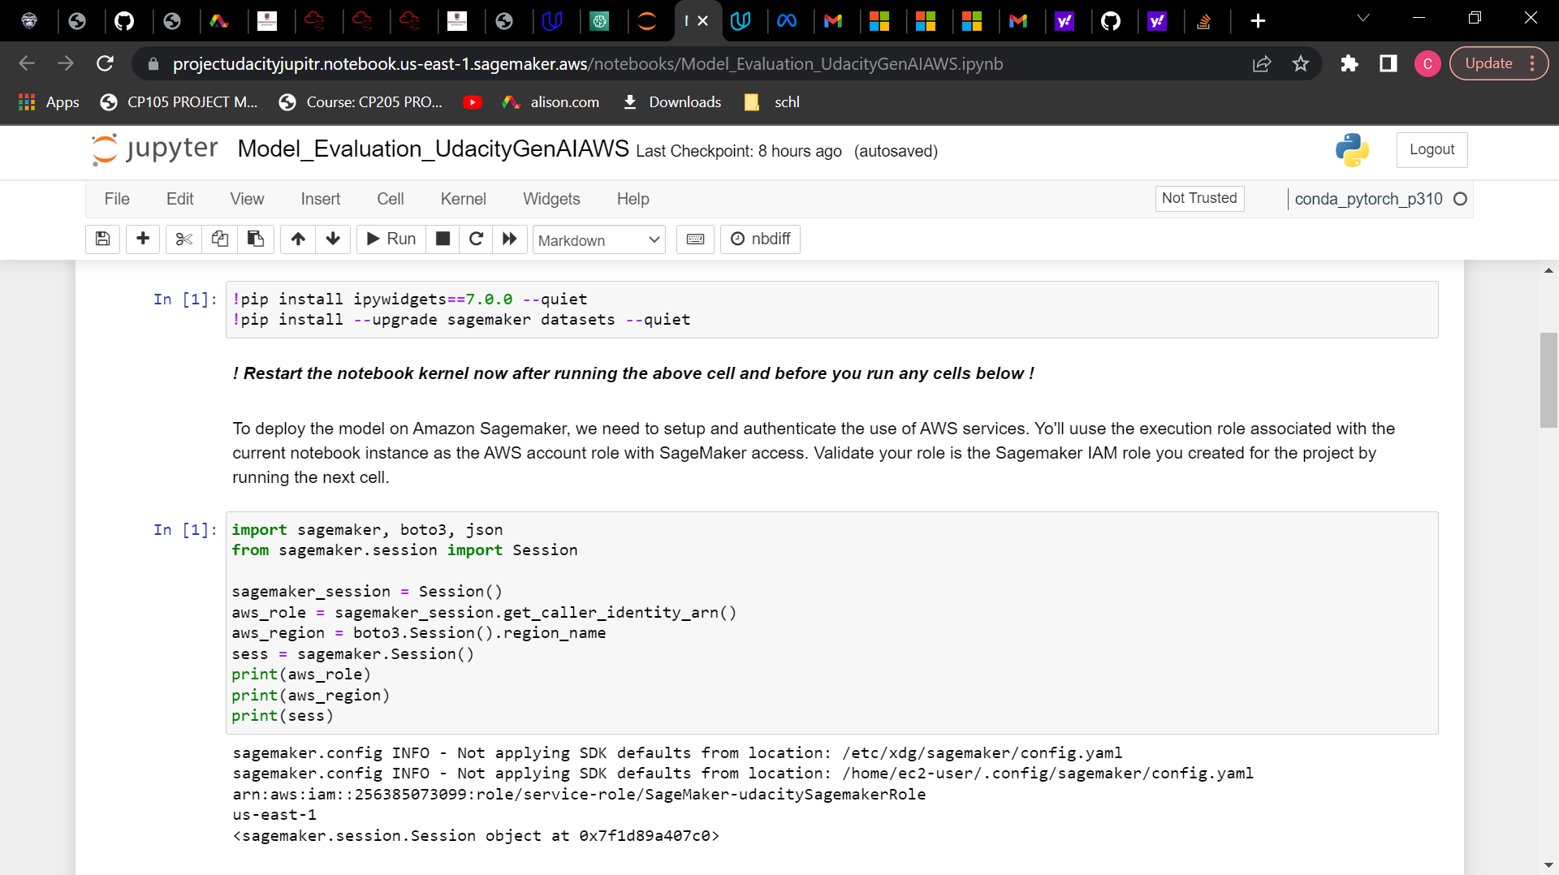

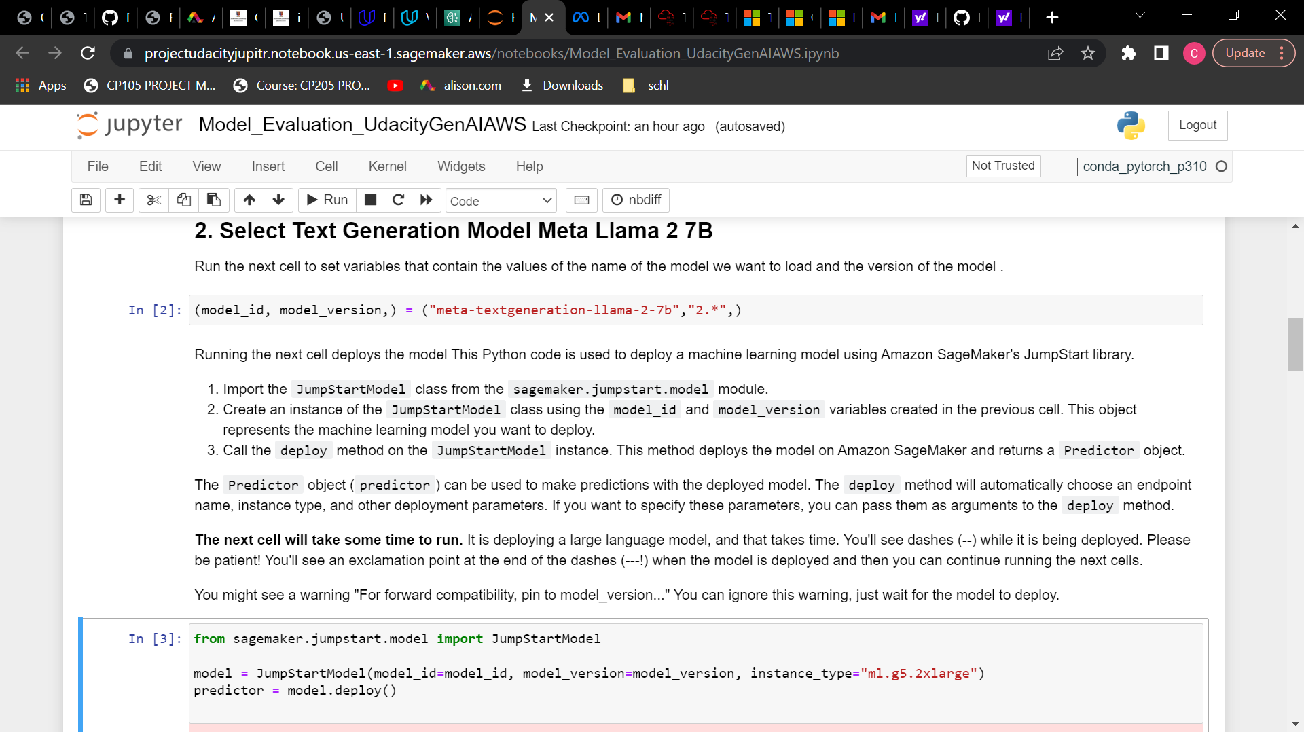

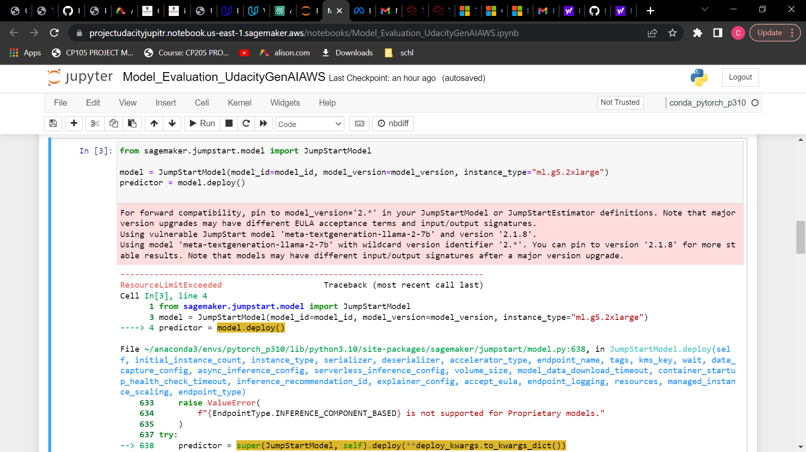

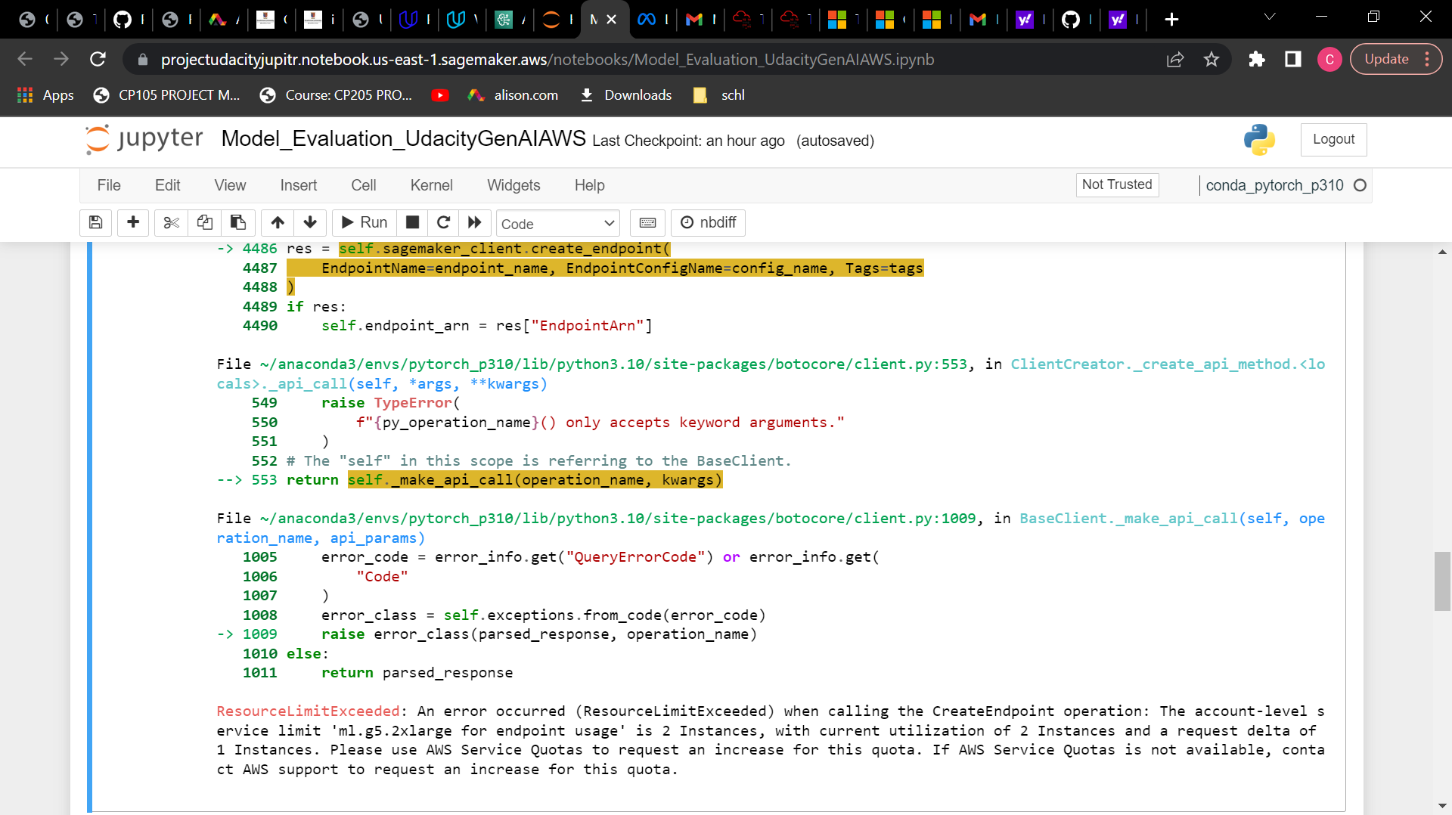

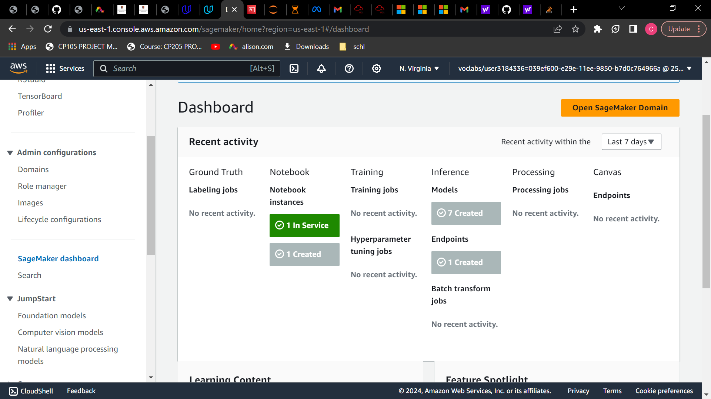

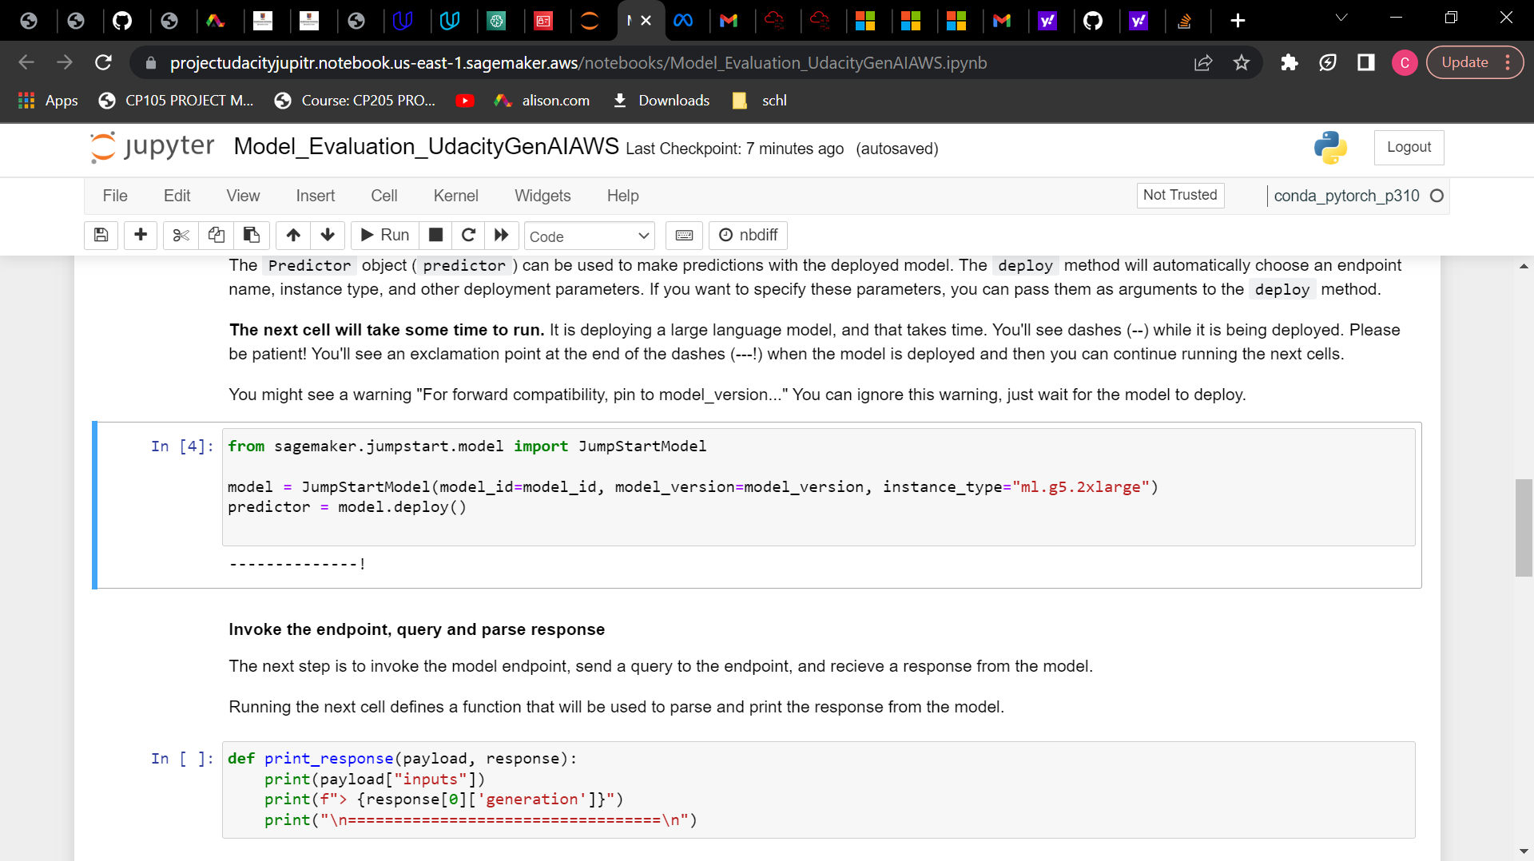

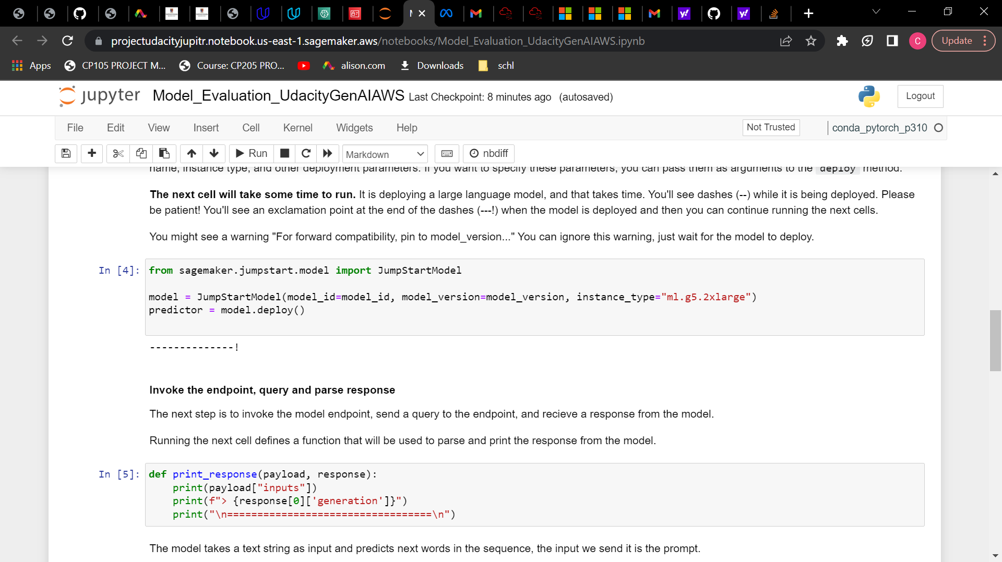

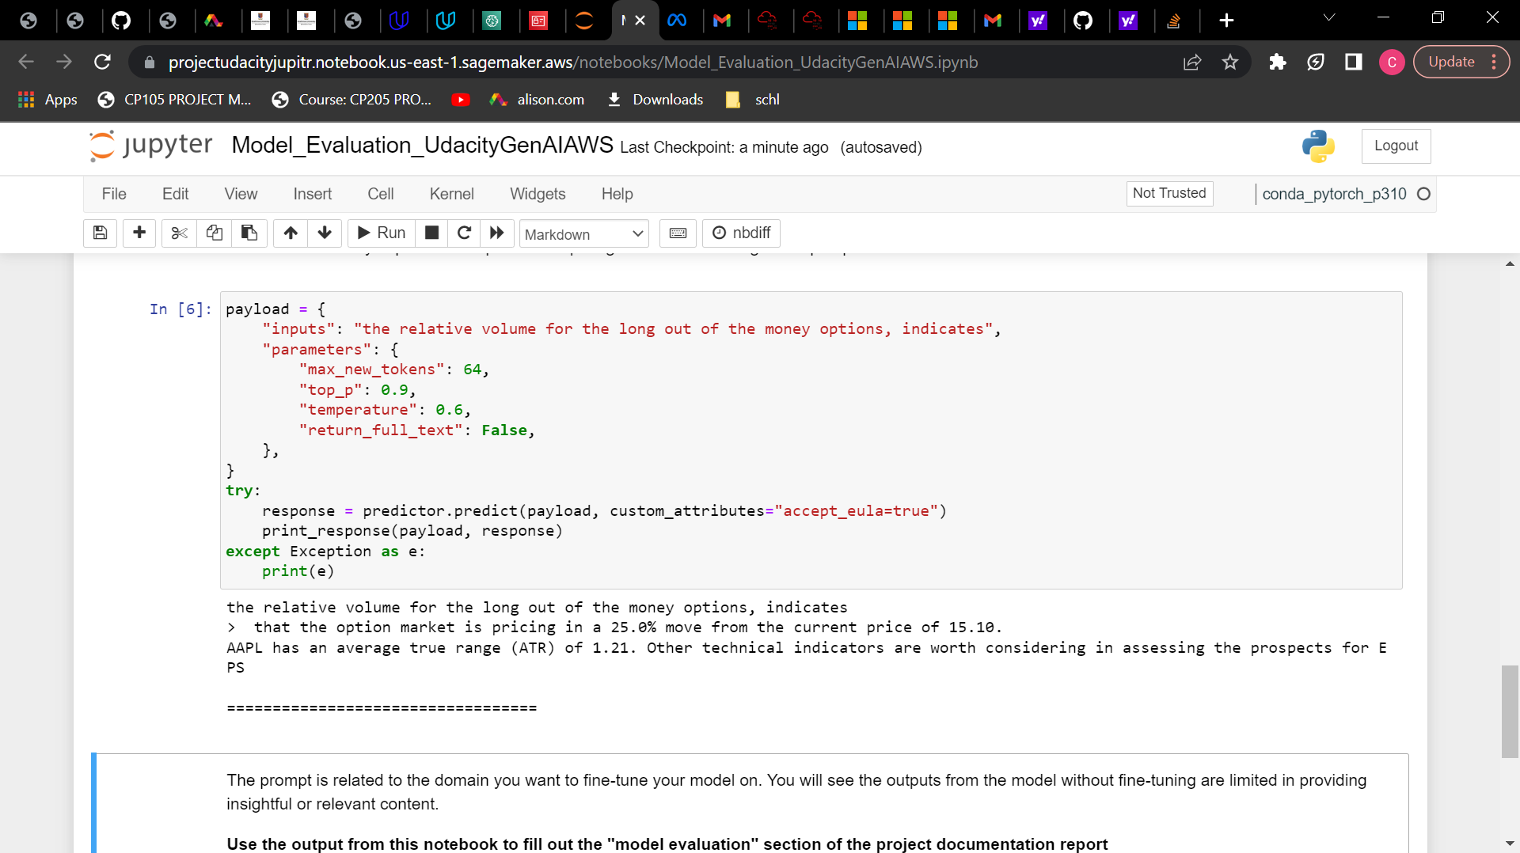

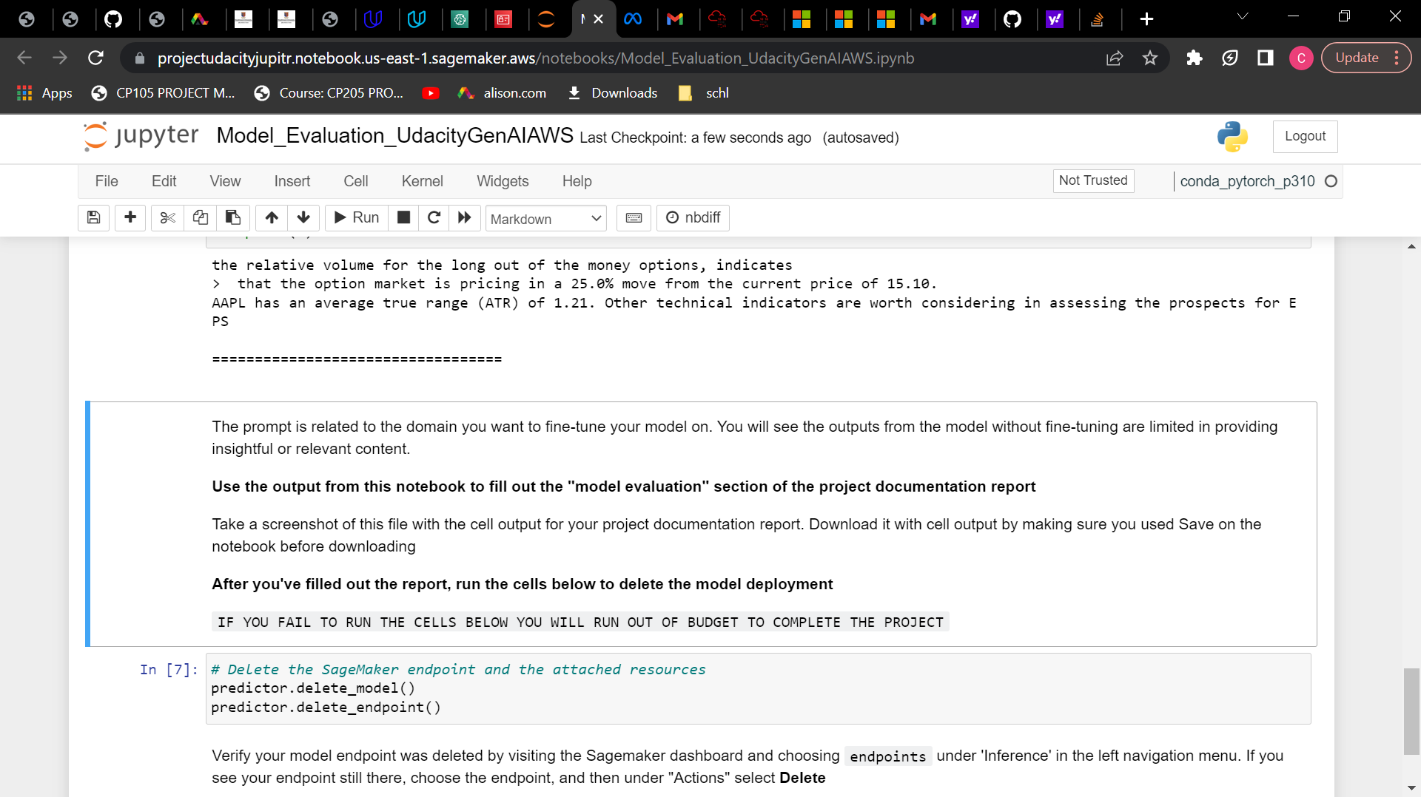

**Step 4: Fine-Tuning Section**

